Experiment No: 7

Experiment Name: Implementation of FCFS Disk Scheduling algorithm.

Objectives:

First Come First Serve (FCFS)

1. Requests are serviced in the order in which they arrive
2. The algorithm is easy to implement
3. Bad algorithm as it may involve lots of unnecessary seek distance

CODE:

#include<stdio.h>

void main()

{

int queue[20],n,head,i,j,k,seek=0,max,diff;

float aver;

printf("enter the max range of disk");

scanf("%d",&max);

printf("enter the size of queue request");

scanf("%d",&n);

printf("enter the queue");

for(i=1; i<=n; i++)

{

scanf("%d",&queue[i]);

}

printf("enter the initial head position");

scanf("%d",&head);

queue[0]=head;

for(j=0; j<=n-1; j++)

{

diff=abs(queue[j+1]-queue[j]);

seek+=diff;

printf("move is from %d to %d with seek %d\n",queue[j],queue[j+1],diff);

}

printf("total seek time is%d\n",seek);

aver=seek/(float)n;

printf("avrage seek time is %f\n",aver);

}

Output:

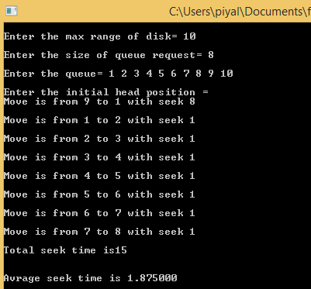

Discussion: In this lab experiment, we learn about FCFS Disk Scheduling algorithm.. We also learn how to implement FCFS Disk Scheduling algorithm by using C program And testing the program different input and find output.We get proper Output from the implementation.